**NAME-ARYAMAN MISHRA**

**REGISTRATION NUMBER-19BCE1027**

**Course Code-CSE2006**

**Course Name-Microprocessor and Interfacing**

**Digital Assignment 2**

1.**Aim:** Write a program to print the value ‘5’ on to the printer using BIOS interrupt.

**Tools Used:**MASM611 toolkit+DOSBOX

**Algorithm:**

Step 0-Start.

Step 1-Load 0Eh interrupt function to AH.

Step 2-Move the number to be printed in character format to AL.

Step 3-Function int 10H is called.

Step 4-Ends.

**Assembly Language Program:**

Assume CS:Code Code Segment

START: MOV AH,0EH

MOV AL,'5'

INT 10H

HLT

Code Ends

END START

**Result**

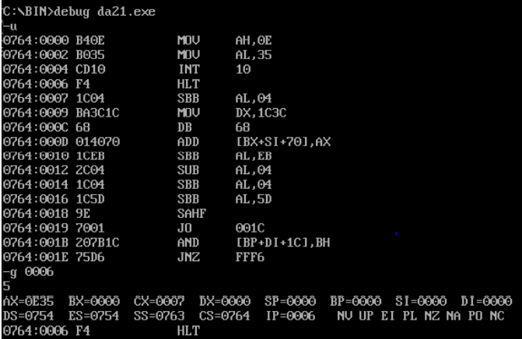

**Observation/Conclusion:**

The number 5 is printed on the screen using BIOS interrupts.

**Difference between DOS and BIOS Interrupts:**

1) When MS-DOS is loaded in the computer INT 21H is used to provide an interrupt to perform some important functions. These are called DOS INT 21H function calls. Main function calls are data input/output through keyboard.

2) The INT 10H subroutines are burned into the ROM BIOS of the 8086 and the compatible hardware and instructions are used to communicate with the user through the screen.

3) BIOS is a firmware that is burnt in ROM and it starts its work on Startup of the processor.

4) It checks whether every hardware connected to the system is proper at the time of booting.

5) For example, it would accommodate date and time settings, keyboard, DVD etc.

6) BIOS is present in the motherboard of the CPU.

7) DOS is Disk Operating System which is the actual OS present in the hard drive initially.

8) While starting the computer, the BIOS checks for all the components connected to the computer, and if they are all fine, then it would make the OS get loaded in RAM for starting it.

**2.a)Aim:** Write an ALP to create a new file, write the string, “Microprocessor and Interfacing – CSE2006 – D2” in the file.

**Tools Used:**MASM611 toolkit+DOSBOX

**Algorithm:**

Step 0-Start.

Step 1-Create the file.

Step 2-Open the file.

Step 3-Write into the file.

Step 4-Close the file.

Step 5-Stop.

**Result:**

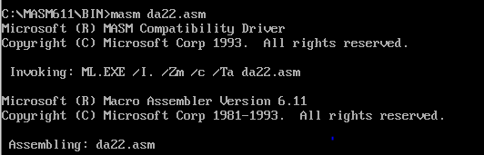

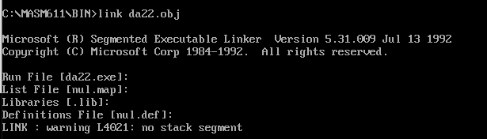

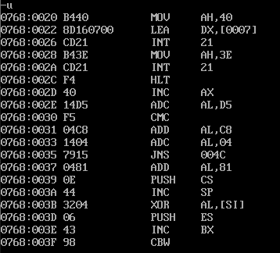

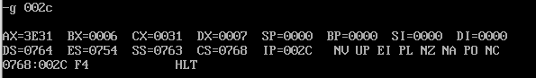

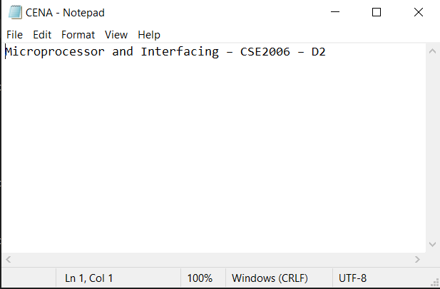

**Observation/Conclusion:**

The file is created with the name “CENA” and the contents were stored into it. The file is created in the BIN of MASM611 folder where all the other programs are stored and executed.

**2.b) Aim:Write an ALP to create a new file and rename the file. The new name must be your first name. For eg., If “Newfile” is the file that I have created, then I should write an ALP to rename it as “Florence”.**

**Tools Used:**MASM611 toolkit+DOSBOX

**Algorithm:**

Step 0-START.

Step 1- Rename the file given in the (a) part of the question.

Step 2- Close the file.

Step 3- Stop.

**Assembly Language Program:**

Assume CS:Code,DS:Data

Data Segment

filename db "CENA",00H

new db "ARYAMAN",00H

Data ends

Code Segment

START:

MOV AX,Data

MOV DS,AX

MOV DL,3

MOV ah,0eH

INT 21H

MOV AX,seg filename

MOV DS,AX

MOV ES,AX

MOV BX,AX

MOV AH,56H

LEA DX,filename

LEA DI,new

INT 21H

HLT

Code Ends

END START

**Result:**

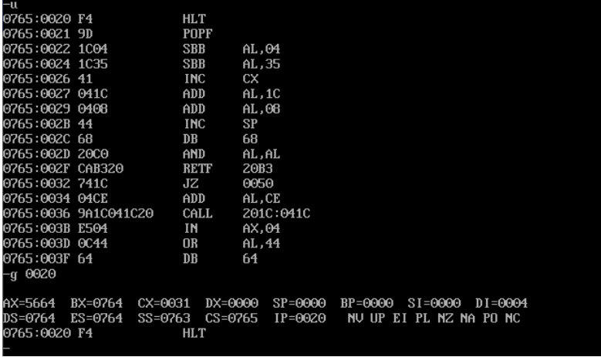

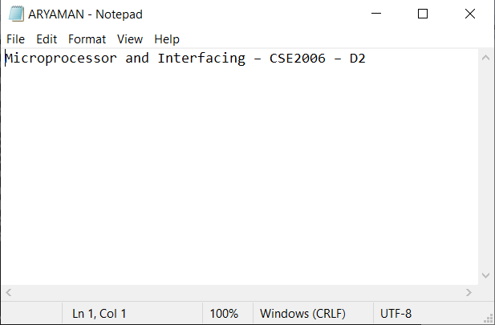

**OBSERVATIONS/CONCLUSION:**

The file “CENA” created in the (a) part of the question is renamed to “ARYAMAN”. The contents and directory remains the same for the renamed file as it was there during the creation of the file.

**3.a)Aim:** Design a programmable timer using 8254 and 8086. Interface 8254 at an address 0080H for counter 1. Write ALPs for following calculations. Consider that 8254 and 8086 work at 6 MHz frequency 2 MHz respectively.

a) To generate a square wave of 1 ms.

b) To interrupt the processor after 5 ms.

Code:

T=(1/(2*10^-6))=0.5US

Number of T-states(N)=((1*10^-3)/(0.5*10^-6))=(2000)10 states

Control Word Register = 77H

**Assembly Language Program:**

Assume CS:Code Code Segment

START: MOV AL,77H ;control word-initialize 8254

OUT 86H,AL ;counter 0 in mode 3

MOV AL,00 ;00 in LSB

OUT 80H,AL

MOV AL,60 ;60 in MSB

OUT 80H,AL

MOV AH,4CH

INT 21H

HLT

Code Ends

End START

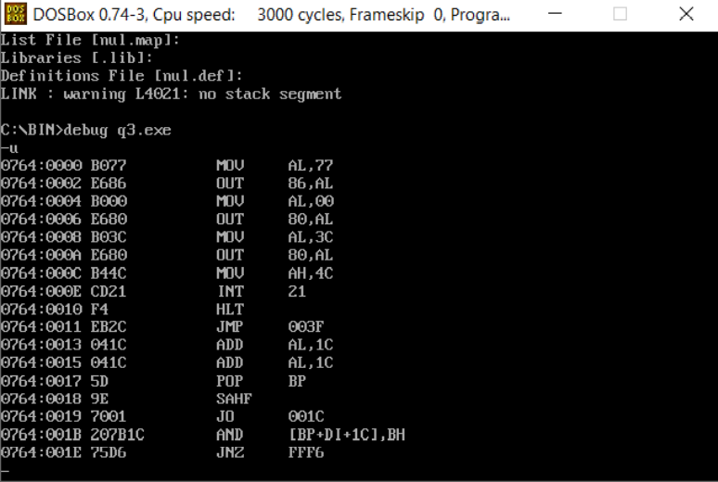

b) Let us select counter 0 for this purpose, that will be operated in HEX mode.

Now suitable count is to be calculated for generating 5ms delay.

No of T states required for 5ms delay = 5×10^−30*16×10^−6 = 30×10^3

N = 30000 = 7530H

Control Word Register: 30H

**Assembly Language Program:**

Assume CS:Code Code Segment

START: MOV AL,30H

OUT 86H,AL

MOV AL,30H

OUT 82H,AL

MOV AL,75H

OUT 82H,AL

MOV AH,4CH

INT 21H

HLT

Code ENDS

END START

Output counter is connected to the interrupt pin of 8086 microprocessor.

